Electronics Documentation

1. Electronics Block Diagram
Show signal and power flow

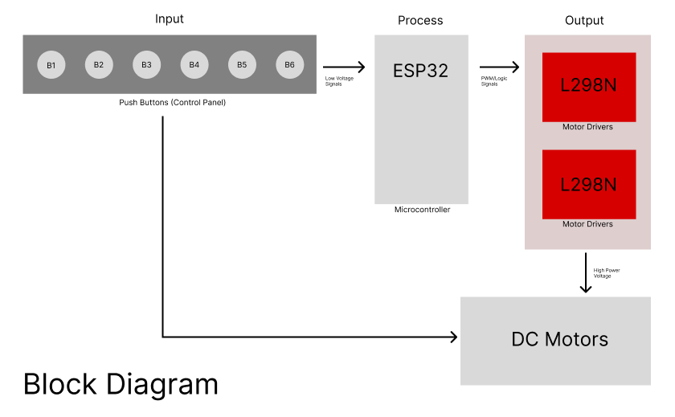

2. Components Table
Component | Quantity | Purpose | Justification
ESP32 Microcontroller | 1 | Acts as the "brain" to read button presses and calculate motor movements. | It has plenty of connection pins for all the buttons and motors, and it is fast enough to do the CoreXY math instantly.
Push Buttons | 6 | To control movement (4 for steering, 1 for up/down, 1 for the claw). | The original analog joystick malfunctioned and was causing drifting issues. Four separate push buttons were used instead to give reliable, exact directional control.
DC Motors | 4 | To move the carriage (2), drop the string (1), and grab the prize (1). | They provide enough strength to move the parts quickly. A DC motor was specifically chosen for the claw because the original servo motor was too weak to grip anything.
L298N Motor Drivers | 2 | To take high-power electricity from the power supply and send it to the motors. | The ESP32 chip is too weak to power the heavy motors by itself. One driver runs the two moving motors, and the second driver runs the drop and claw motors.
Timing Belts & Pulleys (Nylon) | - | To pull the claw carriage around the box. | Required for the CoreXY design. They turn the spinning motion of the motors into smooth, sliding movement for the claw.

